**What is cloud computing?**

**Types of services?**

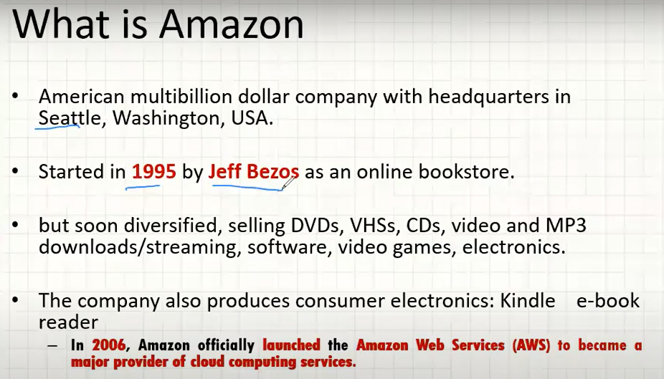

AWS started in 2006.

**-AWS is a cloud platform. AWS is a collection of services. AWS provides 384+ services.**

**Each service is having specific functionality.**

Service means?

We all use **Google drive**, it is a service given by Google. It provides **storage service**. Means we are using cloud storage service since from long back.

Gmail is an **email service** we are already using. These combinations of services called as cloud platform.

Below is the official URL for the AWS website.

<https://aws.amazon.com/>

After logging in we can see list of services like below.

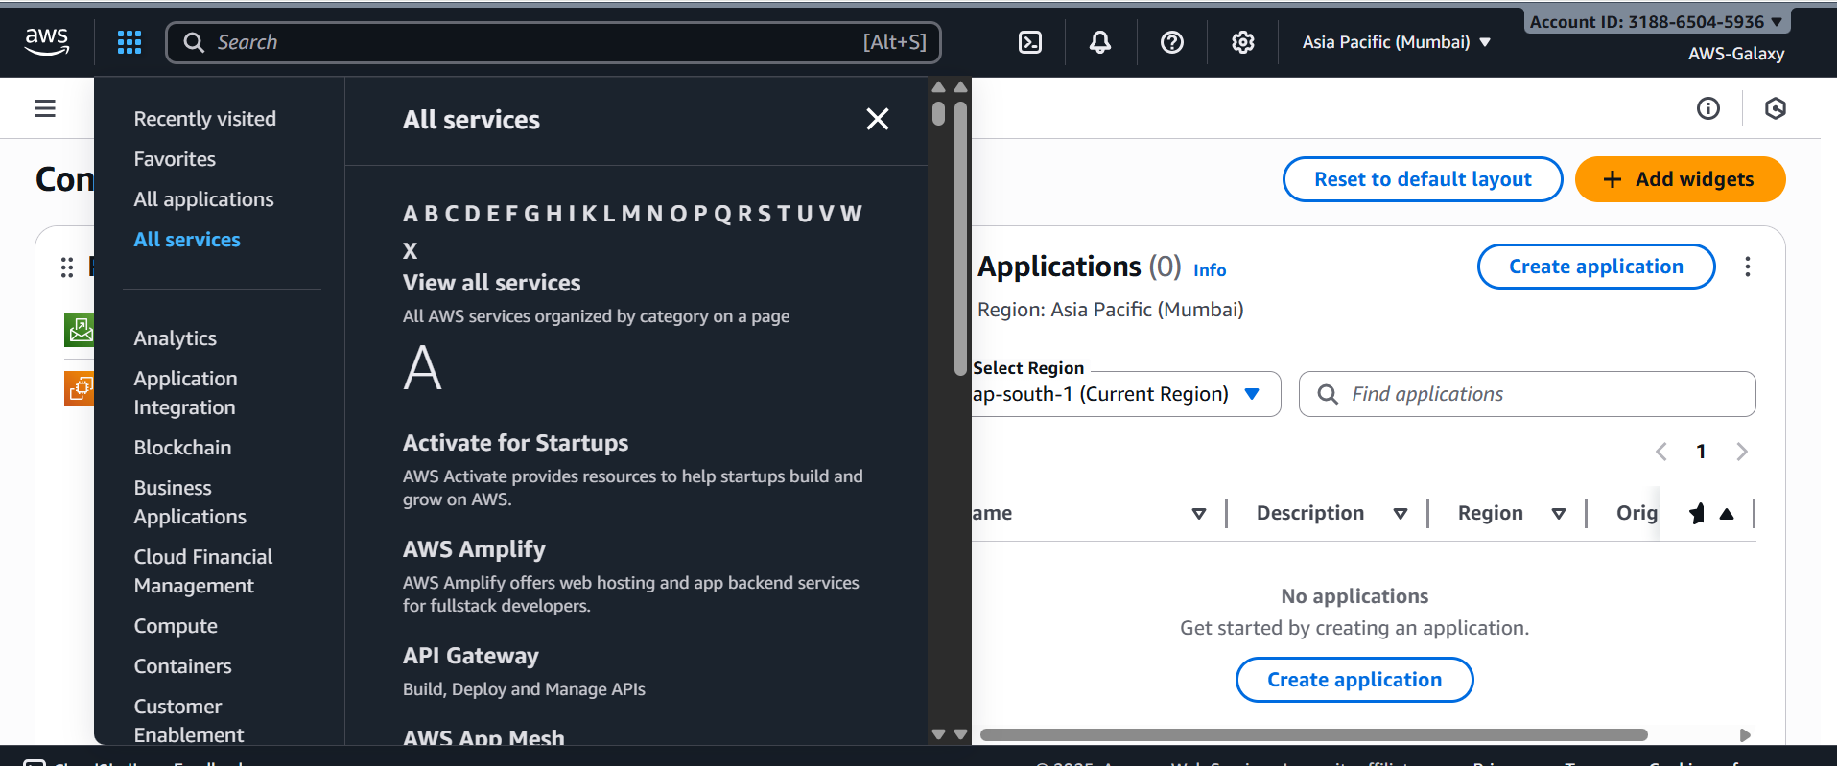

We have so many services we can see and use them.

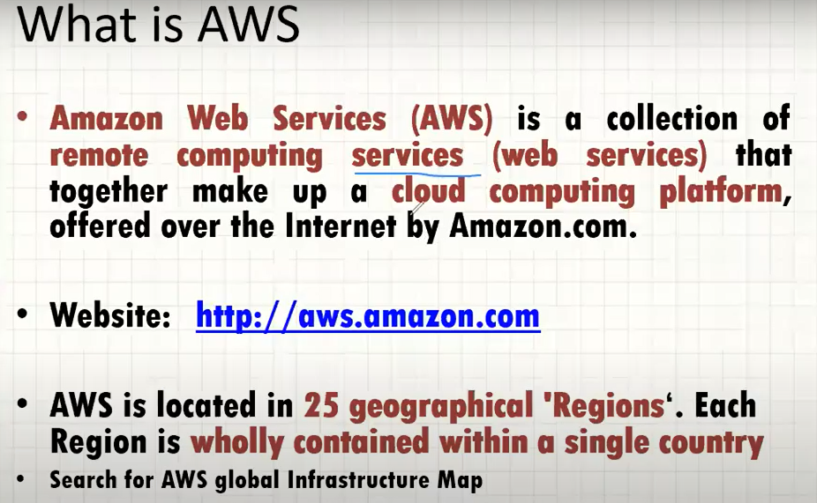

Currently there are 32 regions.

To provide all these services AWS has **data centers / regions**. We can see all regions/data centers in AWS account.

We can see all AWS data centers by searching AWS infrastructure in Google.

<https://aws.amazon.com/about-aws/global-infrastructure/>

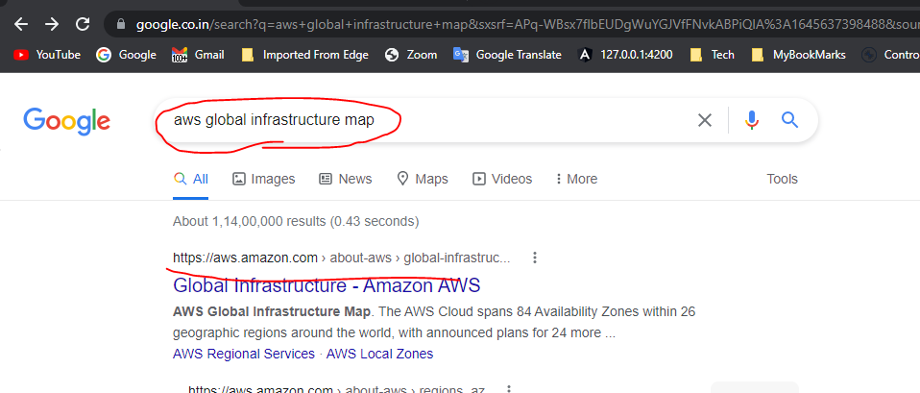

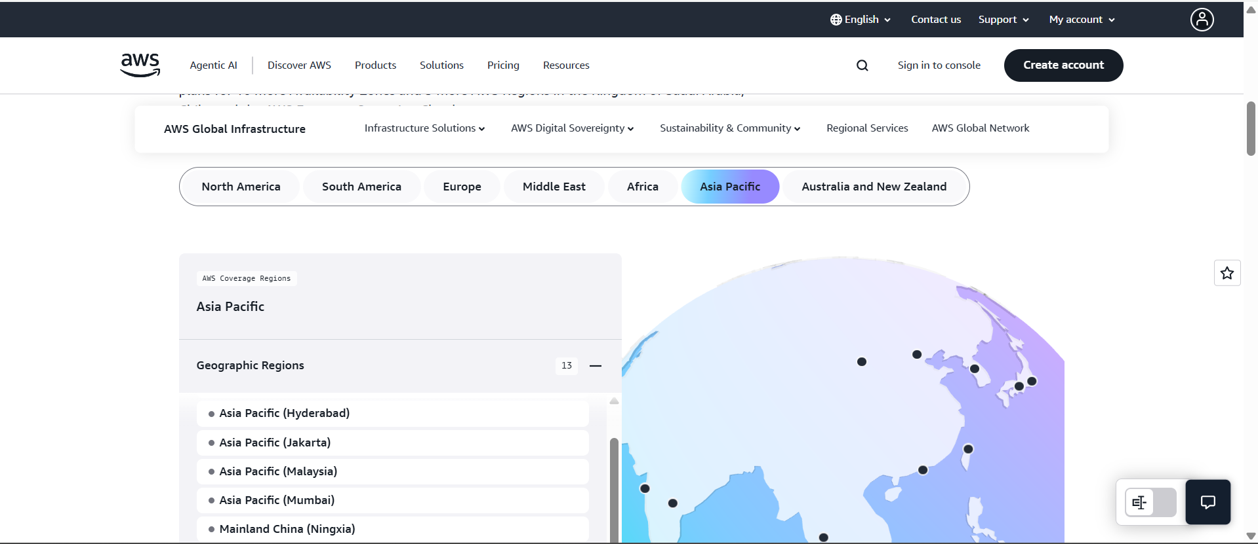

From above we can observe that blue dots are existing regions and yellow dots represent coming soon data centers.

**Regions are nothing but data centers.**

If you click ondata centers, we can see the **Availability zones and Local zones**.

For Mumbai we have 3 availability zones and it is started in 2016 year.

For Hyderabad we have 3 availability zones and it is started in 2023 year.

What is the difference between region, availability zone and date center?

All data centers (Regions) have availability zones.

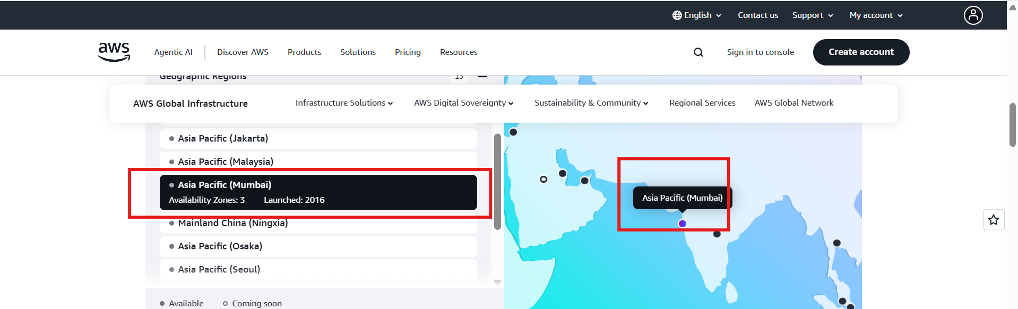

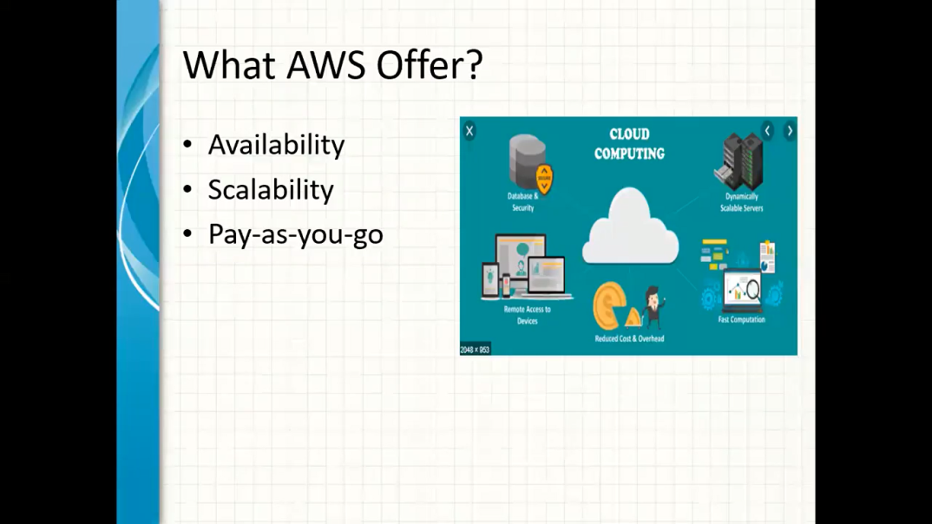

AWS is cloud platform it provides above features these are the advantages.

Availability means all services should be available anywhere.

For example, pen drive not provides availability when it is at home, it is not available for us to use when we are outside of the home / town. But if you store the data in cloud services like Google drive it is always available from anywhere. But internet connection is required.

AWS provides 100% avaialability. There is no down time for services in AWS. Even disaster situation also can be handled in AWS.

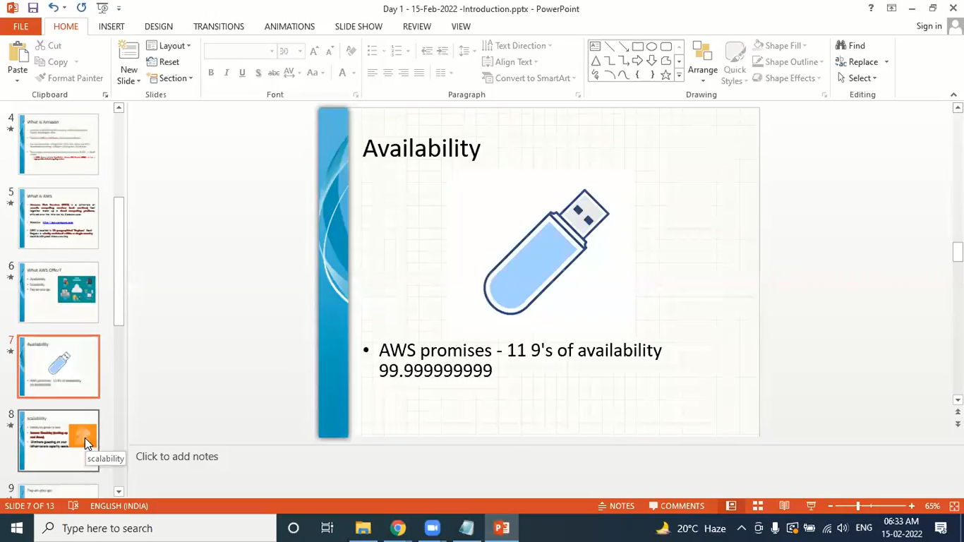

Scalability:

Ability to grow in **hardware** size automatically depends on requirement / requests.

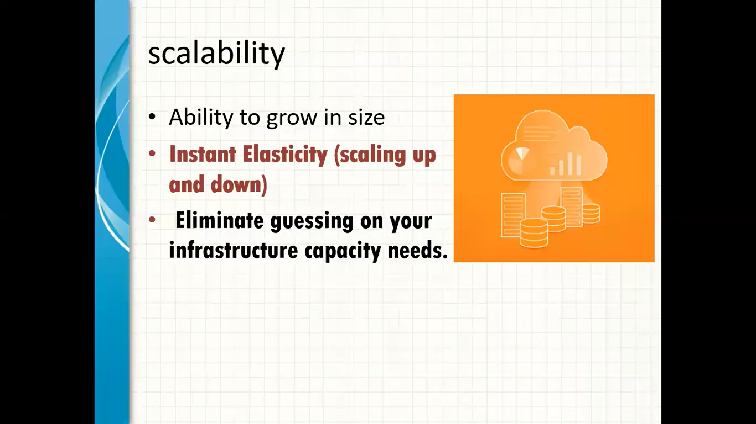

Based on business requirement increasing hardware configurations possible by scalability.

**Pay-as-you-go:**

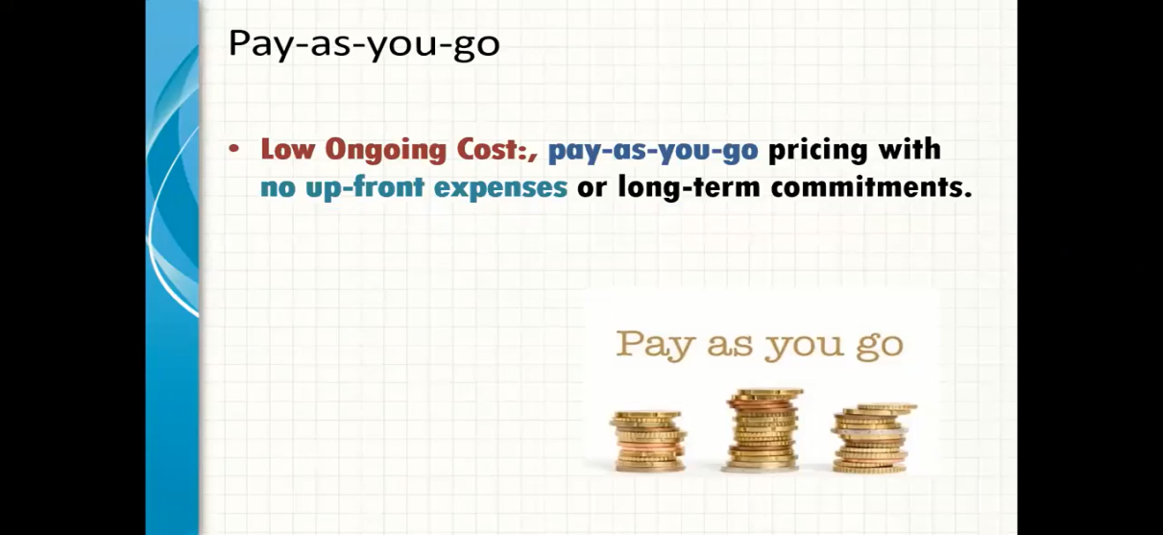

Eg: OTT platform. First pay and then use the OTT service. E.g.: prime video, hot star.

To travel from one place to another place we have so many ways. For example, we can buy a car and we can hire a driver to travel this is called **UP-FRONT investment**. Means before travelling itself we are investing.

Hire a car it is a service for example Uber or OLA it is called **pay-as-you-go**. How much far you travel that much amount only we need to pay, no upfront charges. After using the service only, we need to pay.

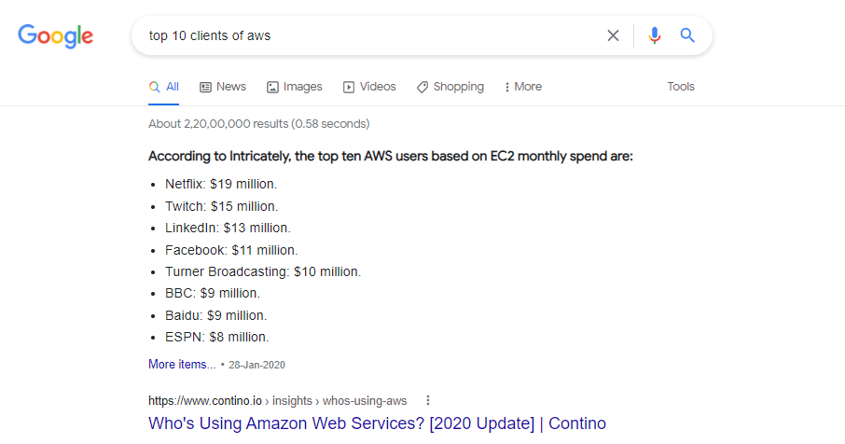

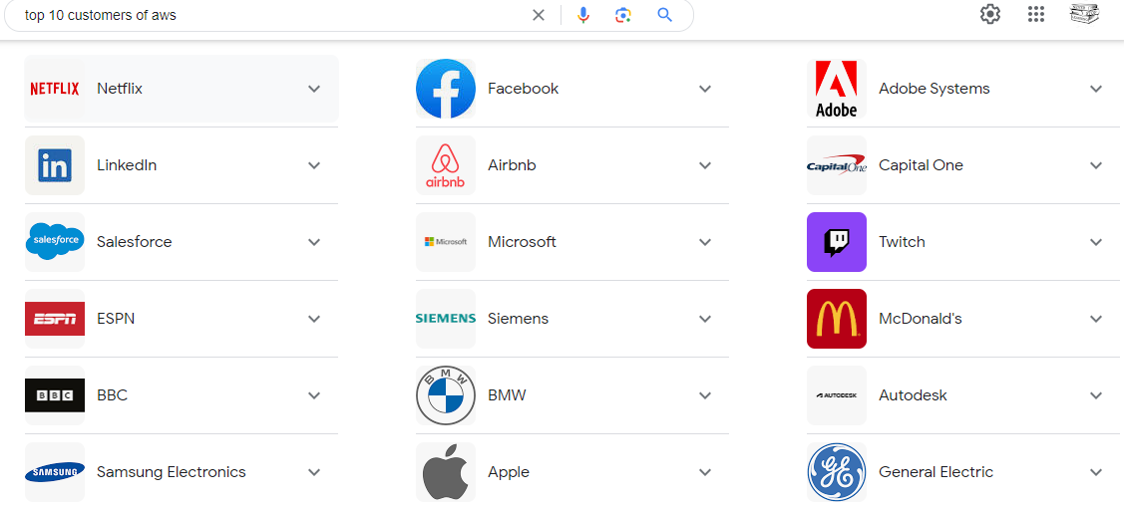

**What are the top leading cloud platforms?**

**AWS (Amazon Web Services)**

**Microsoft AZURE.🡪It is also collection of service.**

**GCP (Google Cloud Platform)**

IBM cloud

Oracle Cloud

Alibaba Cloud - China

In the **garner survey** AWS is the top most cloud technology.

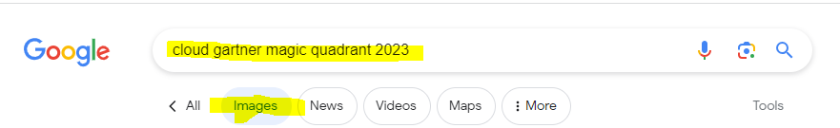

<https://aws.amazon.com/blogs/aws/read-the-2023-gartner-magic-quadrant-for-strategic-cloud-platform-services/>

<https://azure.microsoft.com/en-us/blog/microsoft-is-a-leader-in-the-2023-gartner-magic-quadrant-for-cloud-ai-developer-services/>

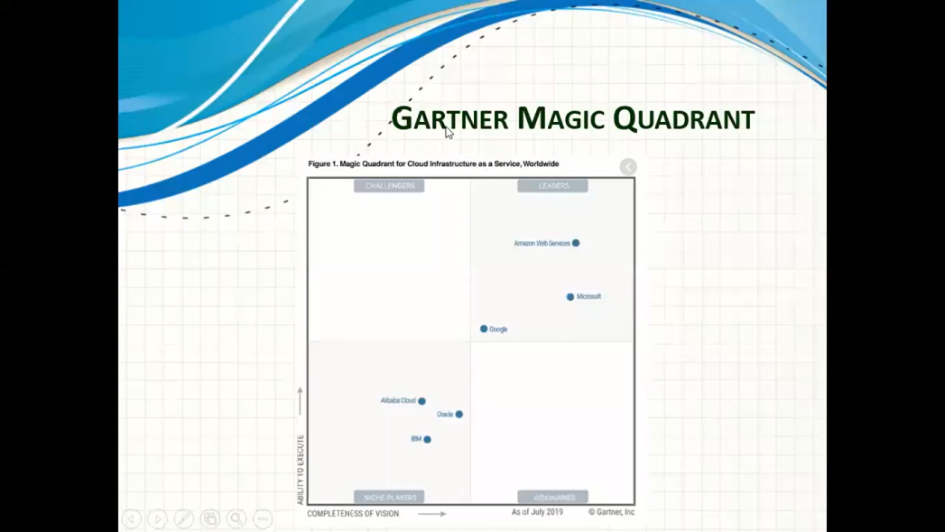

New: latest statistics. 2023:

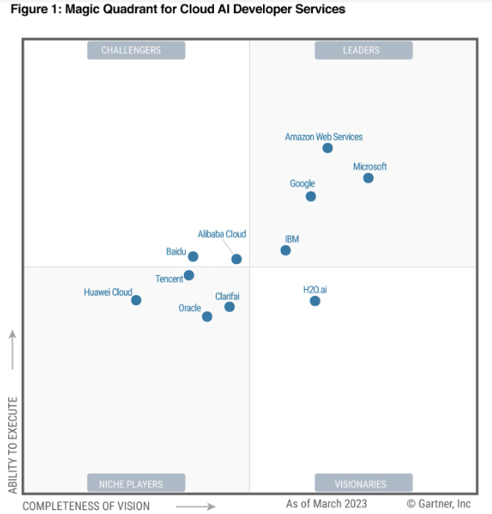

Below are the list of services we are going to learn.

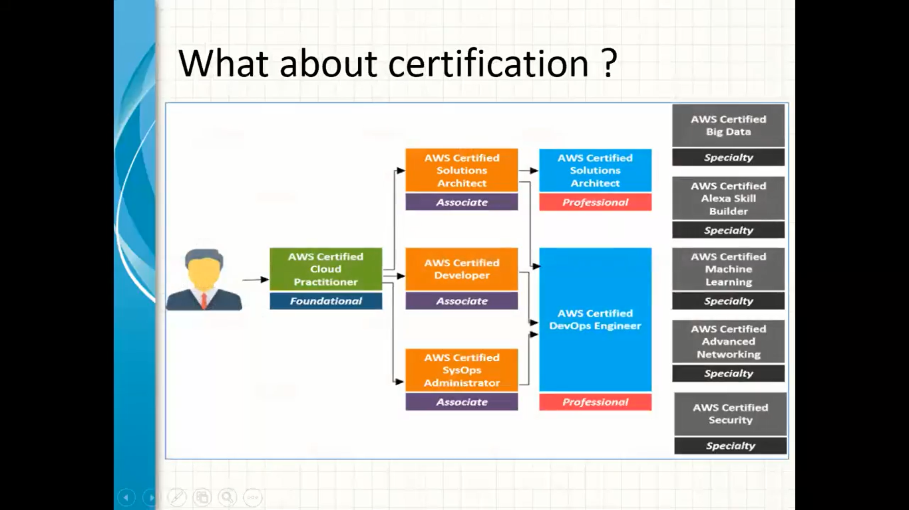

AWS Services:

1. **Free tier service – we use these services only for learning.**
2. Paid service

**Day: -3: - 27-Aug-2025:**

**Day: -3: - 27-Aug-2025:**

**Day: -3: - 27-Aug-2025:**

**Day: -3: - 27-Aug-2025:**

**Day: -3: - 27-Aug-2025:**

**Day: -3: - 27-Aug-2025:**